TAX INVOICE
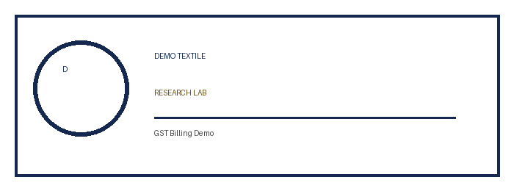 | Demo Textile Research Lab  GSTIN : 00ABCDE1234A1Z0  123 Demo Industrial Area, Sample City - 000000  Email : demo@example.com  Mobile No. : 99999-99999
Details of Receiver (Billed to) |  | GST Invoice No.: | 0001
Name : | Sample Fabric | Invoice Date: | 10/06/2026
Address : | Industrial Area | Despatch Through : | -
Mob. No.- | 88888-88888 | Reverse Charge(Y/N): | -
GSTIN : | 08BCDEF1234B1Z0 | State : Rajasthan | Code : 08
S.N. | Tests | Report No. | HSN Code | Quantity | Amount | Total
1 | GSM Test | DEMO/002 | 998346 | 1 | 1200.00 | 1200.00
2 | Fabric Defect Analysis | DEMO/001 | 998346 | 1 | 3000.00 | 3000.00
3 | Color Fastness Test | DEMO/003 | 998346 | 1 | 2500.00 | 2500.00
Amount | 6700.00
Discount | -
Freight | -
Total Amt. Before Tax | 6700.00
Add: SGST 9% | 603.00
Add: CGST 9% | 603.00
Add: IGST | -
Total Tax Amt. | 1206.00
Total Amt. After Tax | 7906.00
Our Bank - DEMO BANK, Main Branch, Sample City  Ac. No.- 00000000000000  IFSC Code- DEMO0001234  Please Draw The Chq. on the Name of “Demo Textile Research Lab”. | For: Demo Textile Research Lab ,  Authorised Signatory
Total Invoice Amt. In words – RUPEES SEVEN THOUSAND NINE HUNDRED SIX ONLY .
Certified that the particulars given above are true and correct

